COVID-19: World-Wide Country View with an In-Depth View of the US Experience

19 December 2020

Project 2: ETL

Team:
Bunmi Olakanmi
Chris Inalsingh
Moné-Renata Holder
Nihal Joshua

Table of Contents
Introduction: 3
Method: 3
Extract 3
Transform (Transforming the list into Pandas data frame) 7
Load 12
Discussion 12

Introduction:
COVID-19 a disease caused by SARS -CoV-2 corona virus, was first recognised in December 2019. The disease was declared a pandemic by the WHO in March 2020. The reported COVID-19 cases and deaths across the world has been staggering with the highest number of cases and deaths being in the US. So, with the rise in the number of cases and mortality in some regions we wanted to know the trend of the pandemic in Canada and the world over, the economic impact it has had with respect to unemployment and GDP growth, its impact on excess deaths and the relationship between COVID 19 and deaths due to other disease such as Influenza and Pneumonia. To find answers to the above questions that we had, we scraped the web, pulled data from various data sources such as Kaggle, worldometer, ourworlddata in the CSV and json format and extracted them into pandas where we extracted, cleaned, and transformed the data before loading it into SQL.

Method:

Extract
We scraped a web page from worldometer for the continuation of our project on COVID 19. The website is reliable and credible from data around the world and this data on worldometer is updated frequently.
The first thing to scrape a page is to download the page. We download the page by making a GET request to the web server which will download the HTML contents of the webpage. After running the request, we get a response object which has a status code property which indicates if the HTML page has been downloaded successfully. A status code of 200 means that the page has been downloaded successfully.
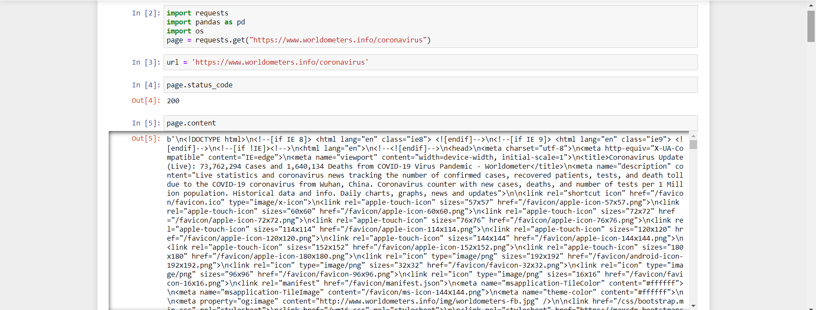

We use Beautiful Soup to parse the HTML document from which we want to extract information.
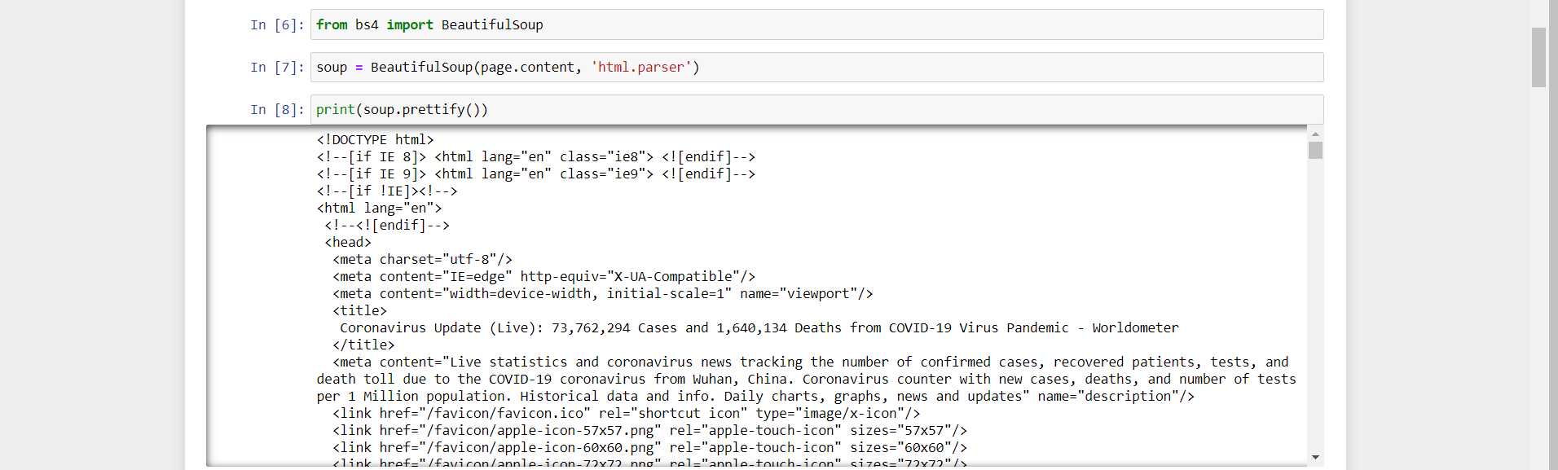
To adequately extract the data from the webpage we must inspect the webpage to find its attributes and tags. We can run inspect by clicking anywhere on the webpage and selecting ‘inspect’. With the regards to this HTML parsing exercise, we are looking for the attributes and tags related to the table on ‘reported coronavirus cases’
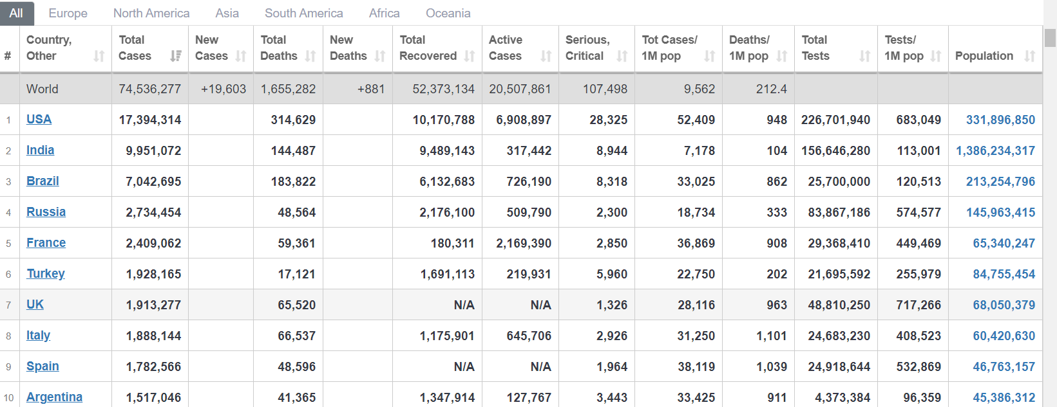
Extraction of Table
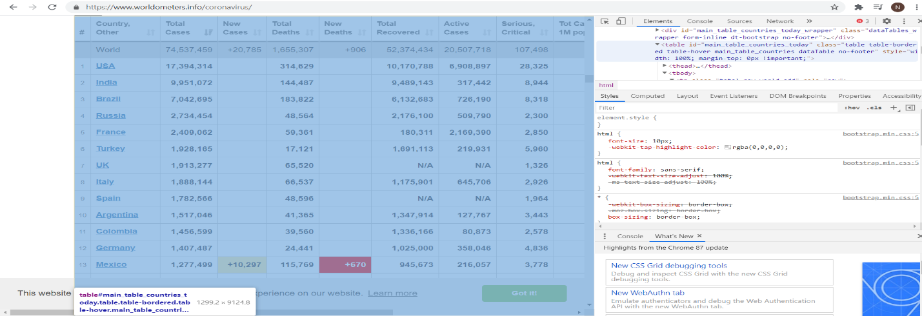
Once the inspection is successfully completed and the attributes ‘id’ is identified the attributes will be used to filter the HTML document to get the required table elements.
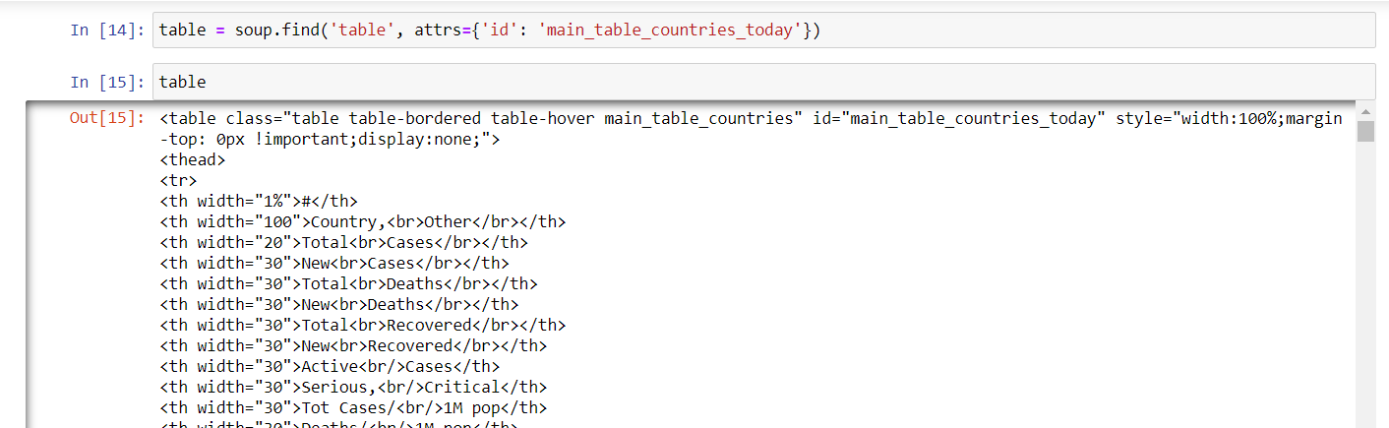

Extracting the text from the extracted the table:
The table that is extracted is basically HTML tags embedded. The goal of the exercise on parsing is to take the table from the webpage and convert it into a data frame for further use such as cleaning and transforming to be loaded into Postgres. To achieve this, we try to retrieve the text on a row-wise basis on a list form first and then convert that list into a data frame. The tags td, tr and th, represent the table column, table rows and table headers, respectively.

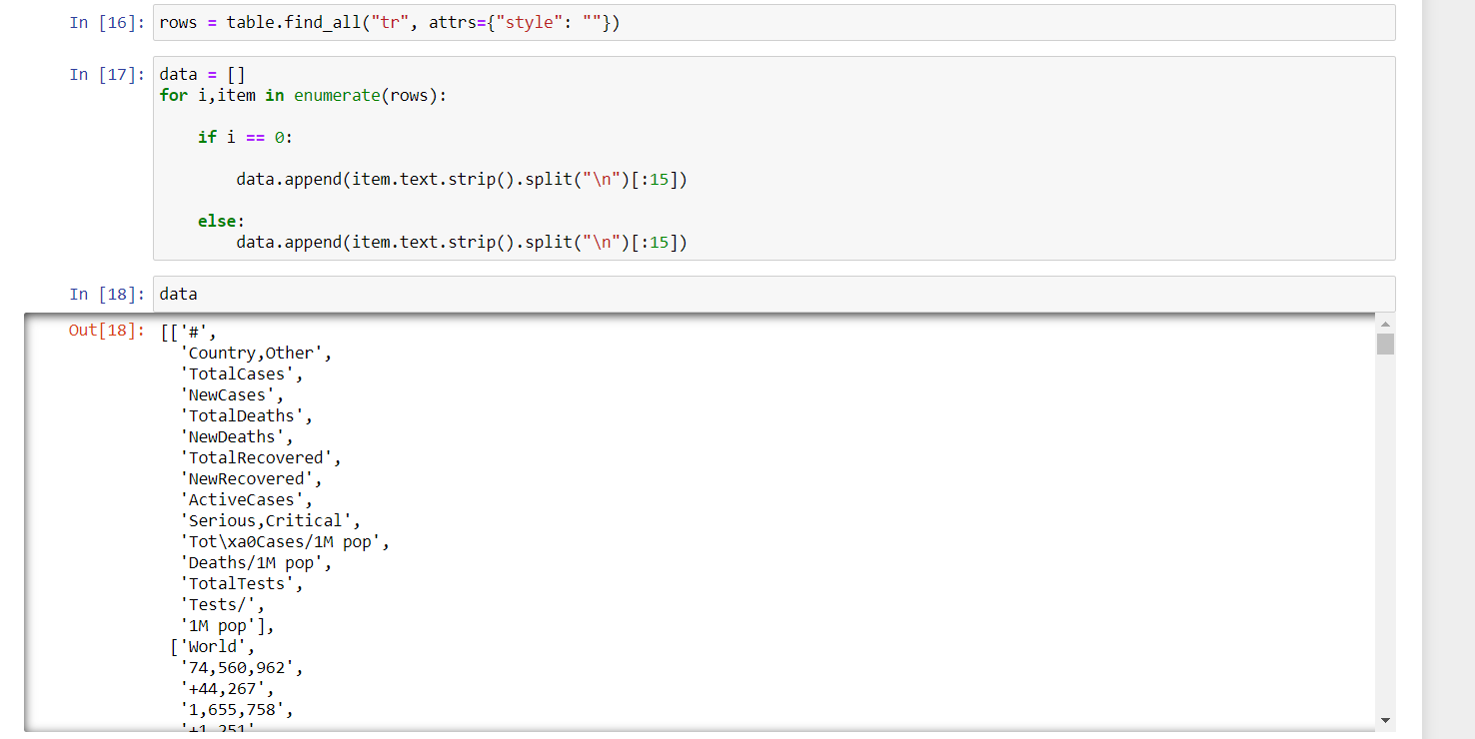
Data sources also used were CSV files of worldwide unemployment rate data, US Pneumonia/Influenza death Data, and excess death data. These CSV files were used in Project 1 where we extracted the data to do regression analysis.

An additional data source we used was a JSON file to capture countries stringency rating between a specified date. The JSON file was first downloaded off the “Our World in Data” site. After downloading the file, empty lists were created and a For Loop was made to append the required data to the empty lists. 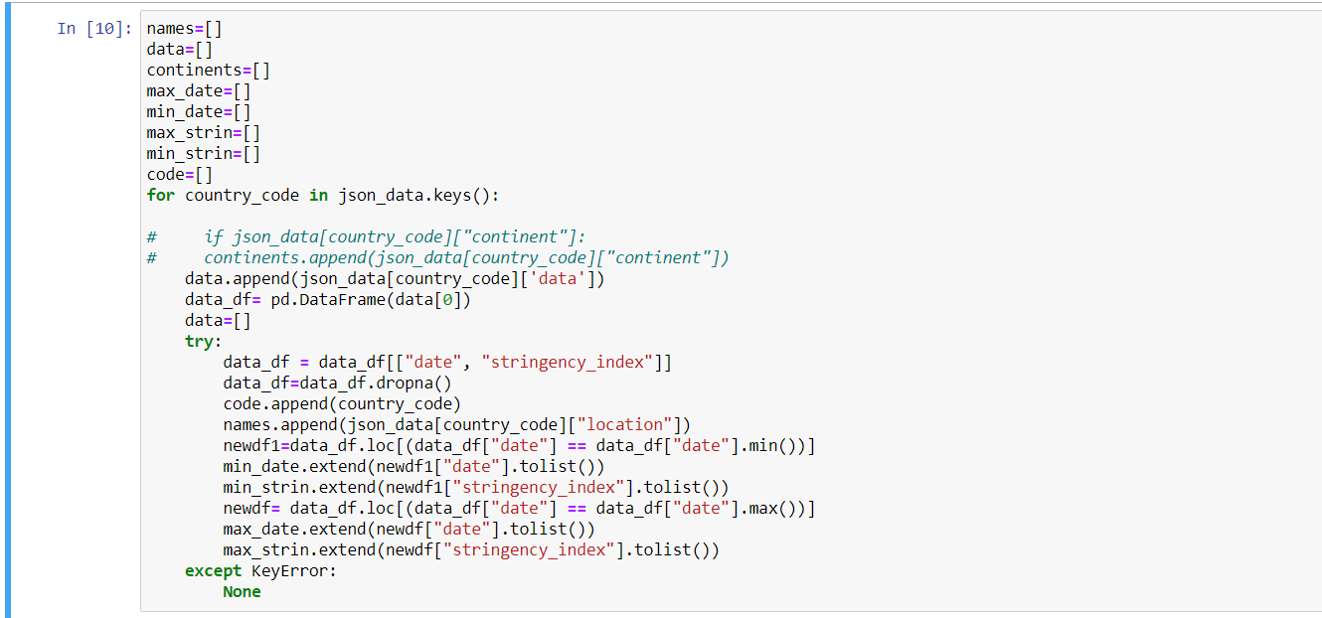

Transform (Transforming the list into Pandas data frame)
The next step for the html parsing data is to convert the list into a data frame. The data is extracted into a pandas data frame and from the pandas data frame the cleaning process by importing pandas into the jupyter notebook.
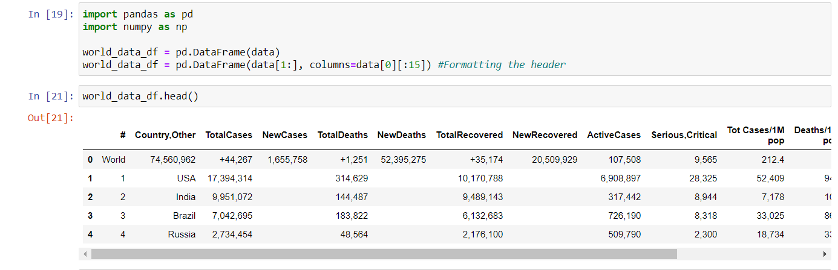

The pandas data frame is cleaned by dropping columns that are not needed.
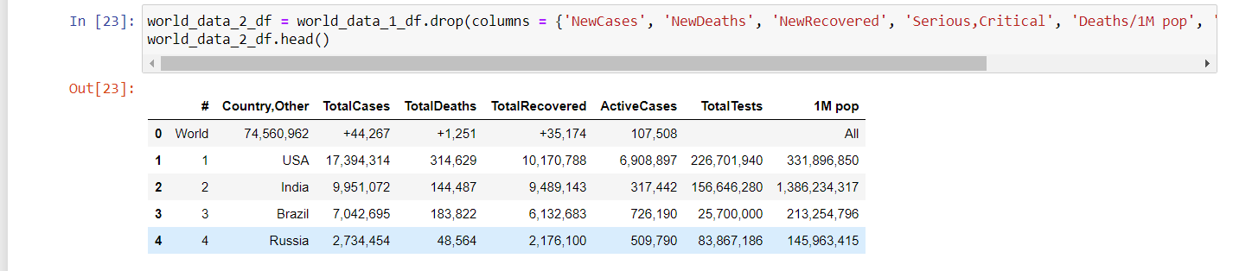

The data frame columns are then renamed.
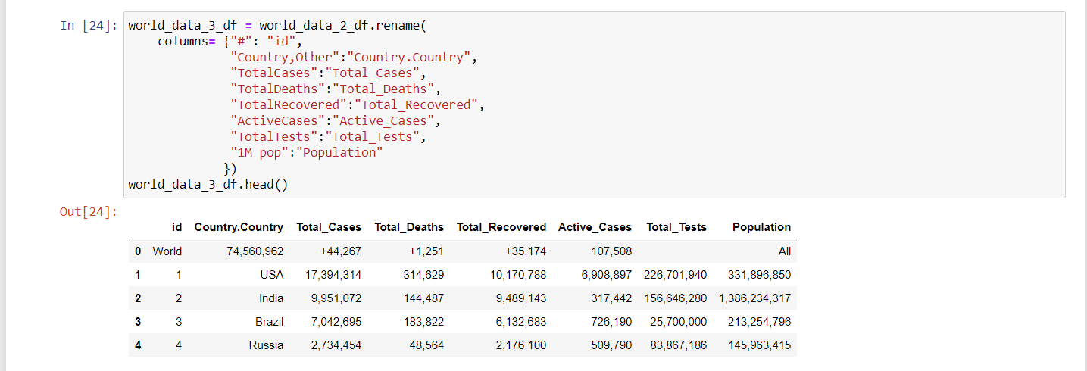

The data frame columns that have unwanted syntaxes are removed and top row which is not needed is dropped as well.
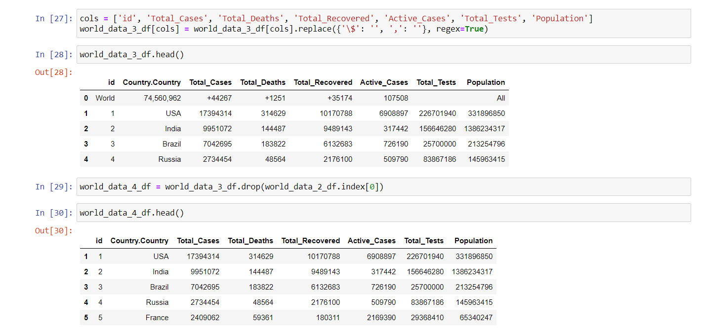

The data frame type is converted from object to integer wherever needed in the columns.
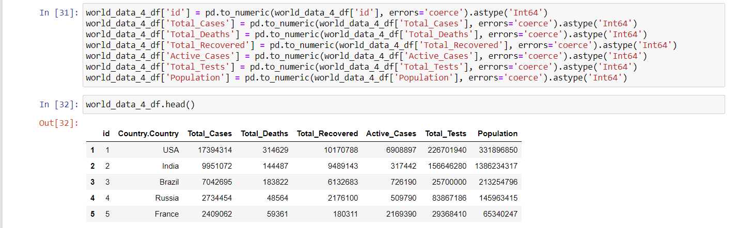
Unemployment Rate CSV data is loaded into pandas to make a dataframe of all columns. Certain location codes were removed as they were not countries (ex G-7, EU27_2020). The unemployment rate data frame was then merged with one created to match the location code with a country name. Irrelevant columns were then removed from the dataframe to only show the March 2020 to September 2020 unemployment rates of multiple countries worldwide.
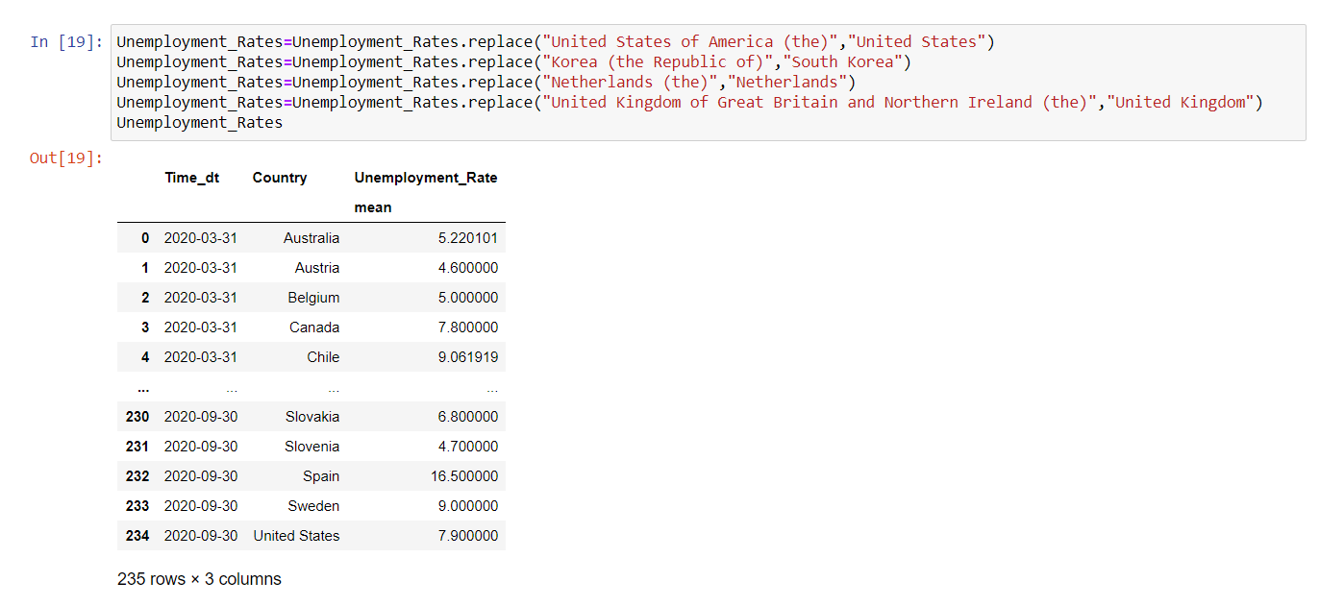
US Pneumonia/Influenza CSV data is loaded into pandas to be made into a dataframe. Data that had jurisdiction of type “HHS Region” were removed to include only US states as jurisdictions. The DataFrame was then grouped by Jursidiction and had irrelevant columns removed to only show COVID-19 Deaths, Total Deaths, and Pneumonia/Influenza Deaths.
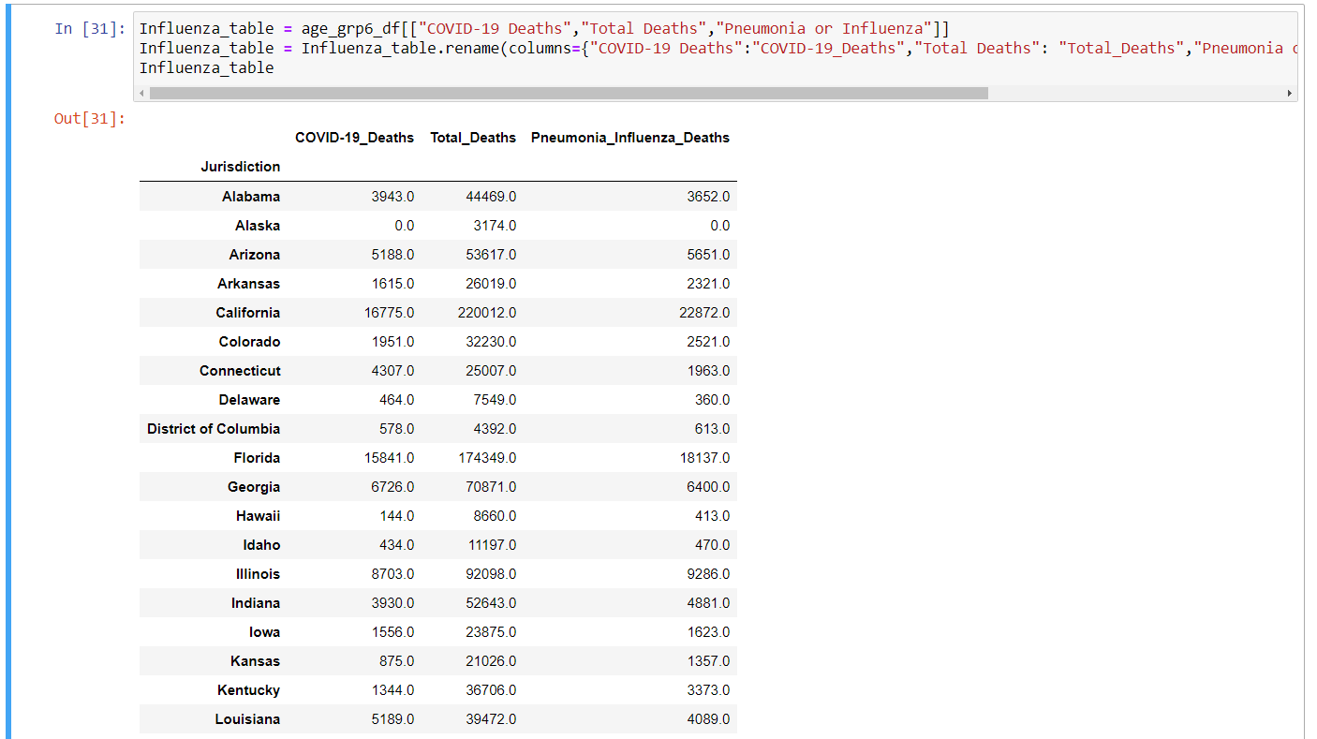

Excess Death CSV data is loaded into pandas to be made into a dataframe. The dataframe is then filtered to have only data for US in 2020. The week period rows is then aggregated and grouped to be per US State to link with the Influenza table during the load phase.
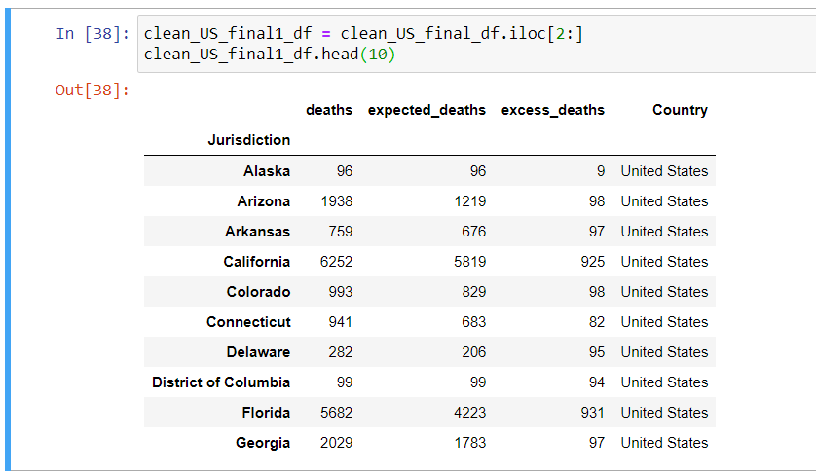

Using the list created from appending the data in the For Loop, a dataframe was created for the country responses data.
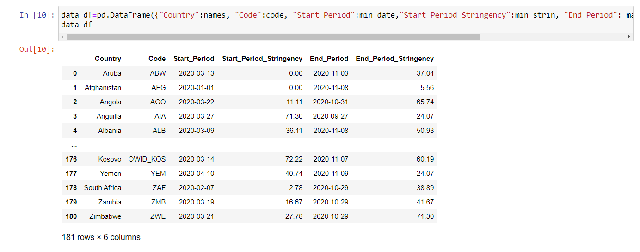
An additional data frame was used to create a table with a column of countries indexed by their respected country code to later be able to link this table to other tables with country columns.
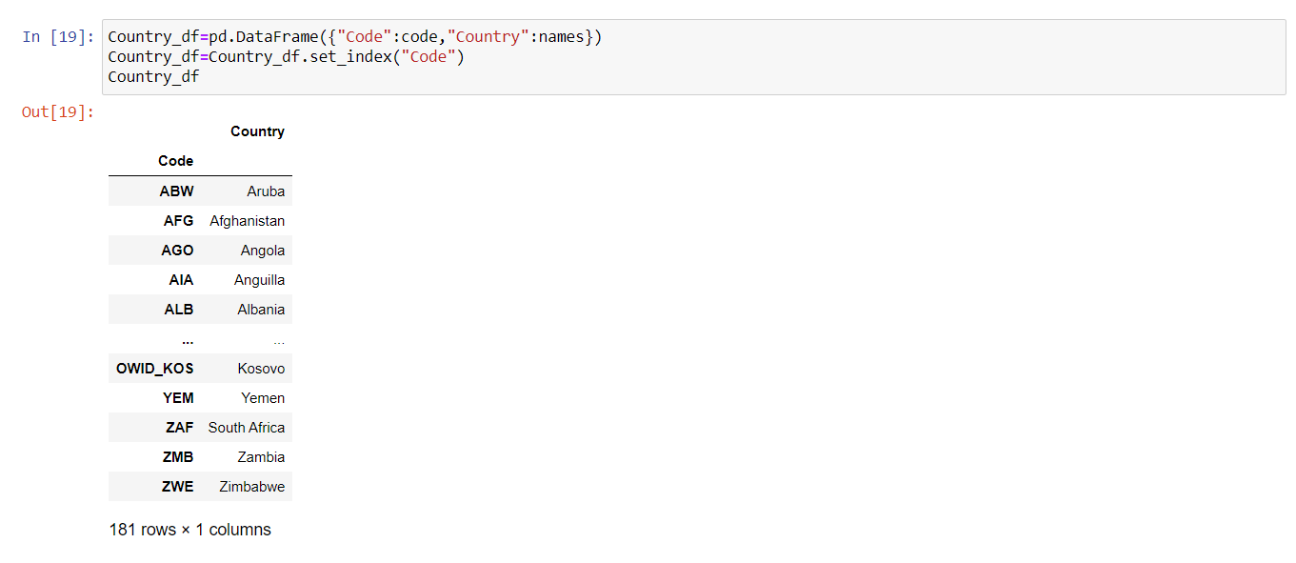

Load

Discussion
Some lessons learned from this ETL Project is that creating an outline of ERD diagram is key to keep all stages of ETL on track with a guideline. Being able to build from Project 1 to apply more knowledge and update the code. Limitations in this project were being able to find data that can have relatable tables that can be linked as most of our tables are linked through Country. With our new knowledge learned from the course, we could use the database tables constructed to upload onto our own website to be displayed.

